**INTERNET PROGRAMMING LABORATORY**

Project Report

(Spring term 2022-23)

Submitted by:

Abhinav Prakash Regn no. 12216799

Surya Prakash Reddy Regn no. 12216082

Prabhat Kumar Singh Regn no. 12219419

Report belongs to Prabhat kumar singh

Section KOC04 Roll no B47

Registration number 12219419

By the guidance of **SUSHIL LEKHI (28857)** Dept of CSE



Computer Science Engineering Lovely Professional University, Jalandhar December-2022

**Content**

1. Student Declaration 03
2. Introduction 04
3. Objectives 05
4. Features of the project 05
5. Screenshots of webpage 06
6. Future scope of work 10
7. Bonafide certificate 11

**1. Student Declaration**

This is to declare that this report has been written by us. No part of the report is copied from other sources. All information included from other source have been duly acknowledged. Each and every line is coded by us. We are that if any part of the report is found to be copied. We shall take full responsibility for it

………………………………..

Abhinav Prakash (12216799)

Roll no A26

………………………………..

Surya Prakash Reddy (12216082)

Roll no A15

……………………………….

Prabhat Kumar Singh (12219419)

Roll no B47

**2.Introduction**

One of the most important steps involved in creating a school web site is deciding what content will be included and how it will be organized. Building a school web site provides a unique addition to the curriculum. In the development phase, students and teachers should discuss the kinds of materials they want to add to the site.

* **School information.** General information such as the school’s telephone number and address along with driving directions should be included. Making mention of the school boundaries is also useful. The school’s history, mission statement, and awards received are interesting and serve to promote a feeling of community.
* **School policy.** The school policy is a very important document that may be made readily available by posting it on the school site. School policy information might include use of the Web in school.
* **Calendar of events.** A calendar of events provides parents, teachers and students with an easy way to keep up-to-date with the happenings at the school. Special events such as school plays, sports, field trips, and standardized tests are just a few examples of what may be included. The school lunch menu may be added to the calendar as well.
* **Extracurricular activities.** School clubs or organizations involved in organizing special events may create their own pages describing their purposes and anticipated activities for the entire year

**3.Objectives**

* We can add information regarding what’s going in school
* All the information’s regarding school will be available so that no need to ask from others every time.
* We can communicate with new parents and people will know about us more.
* We can highlight customer feedback
* We can use it for online schooling
* We can affectively advertise on social media
* We can promote our class and online schooling.
* It will save a lot of time too.

**4. Features of Project**

* Easy and simple to use.
* Proper working of navigation bars
* Social networking
* Using analytics
* Media gallery of school
* Present parent emphasis
* An easy-to-use content management system.

**5. Screenshots**

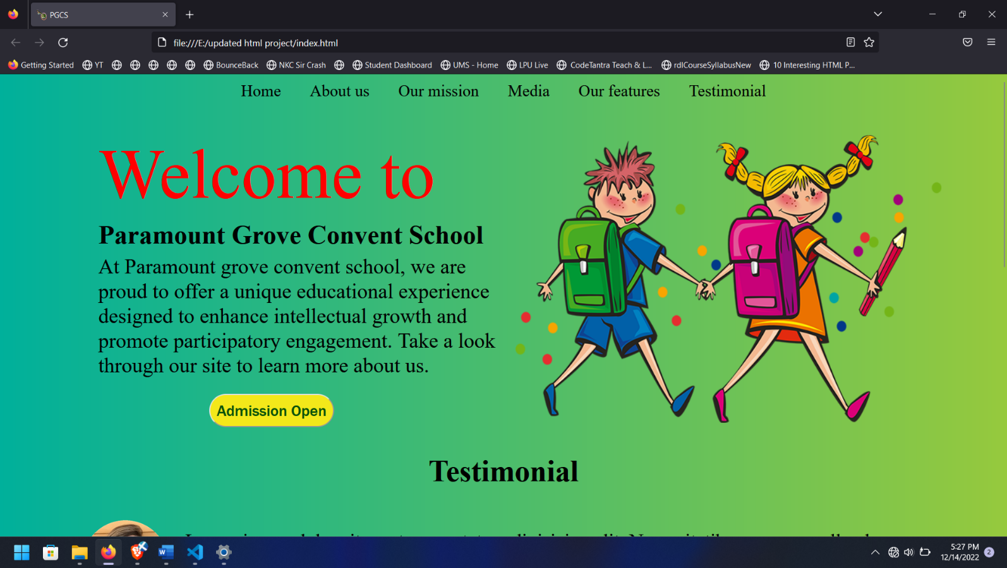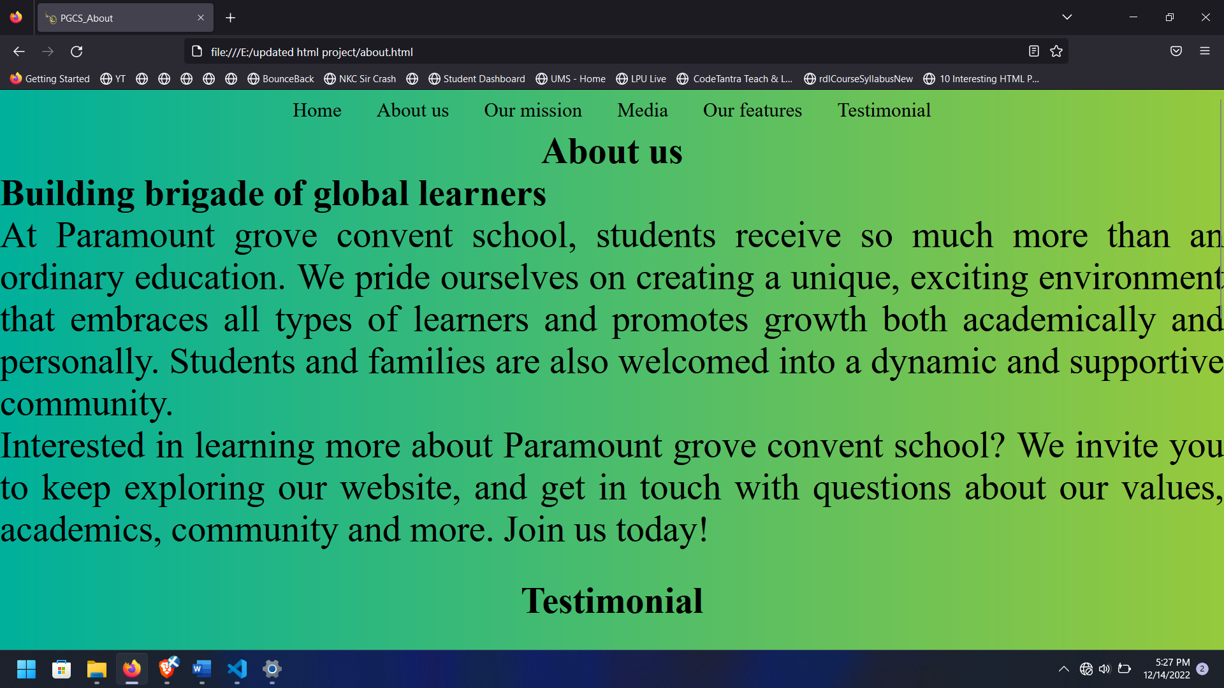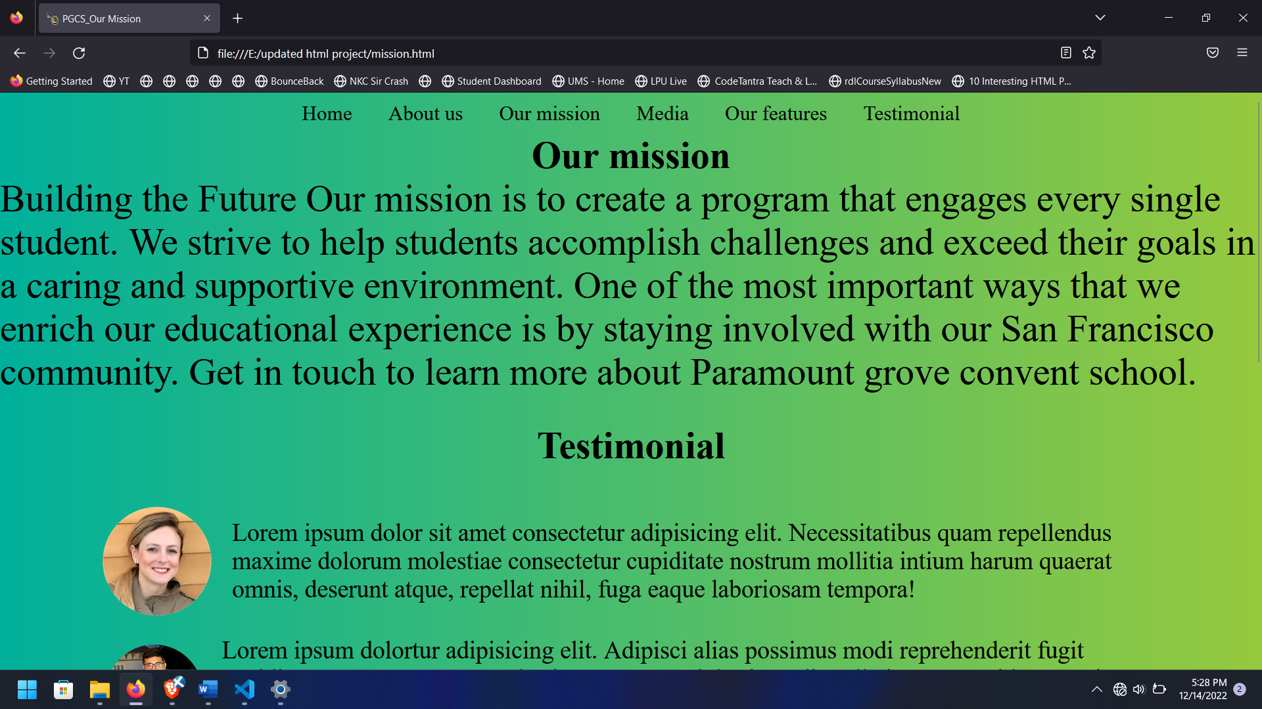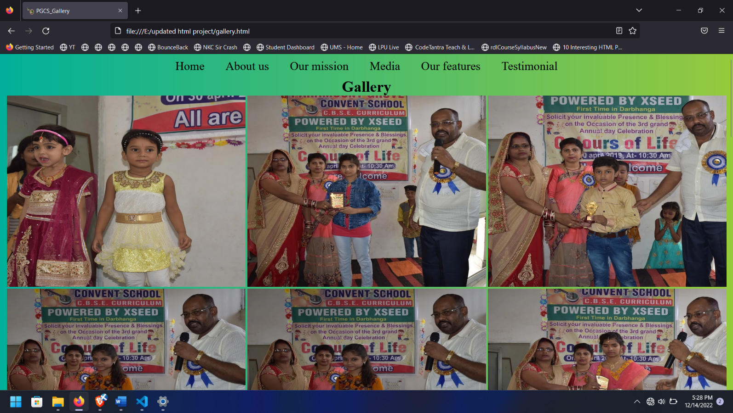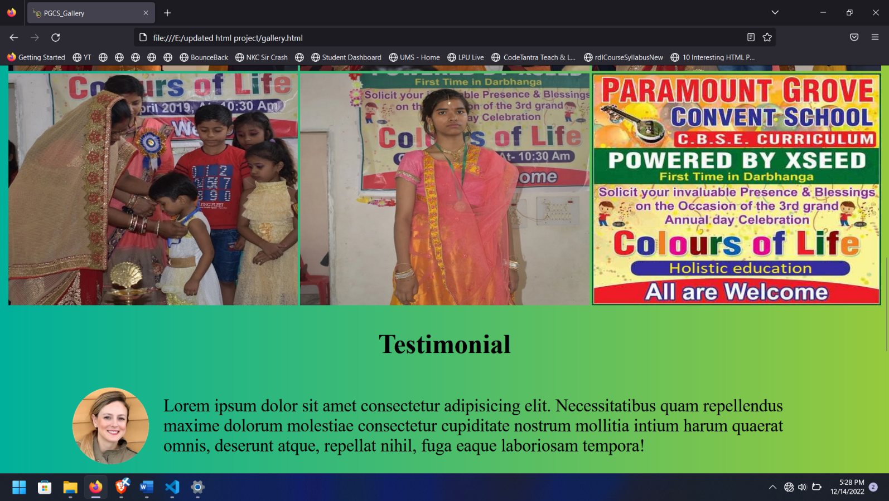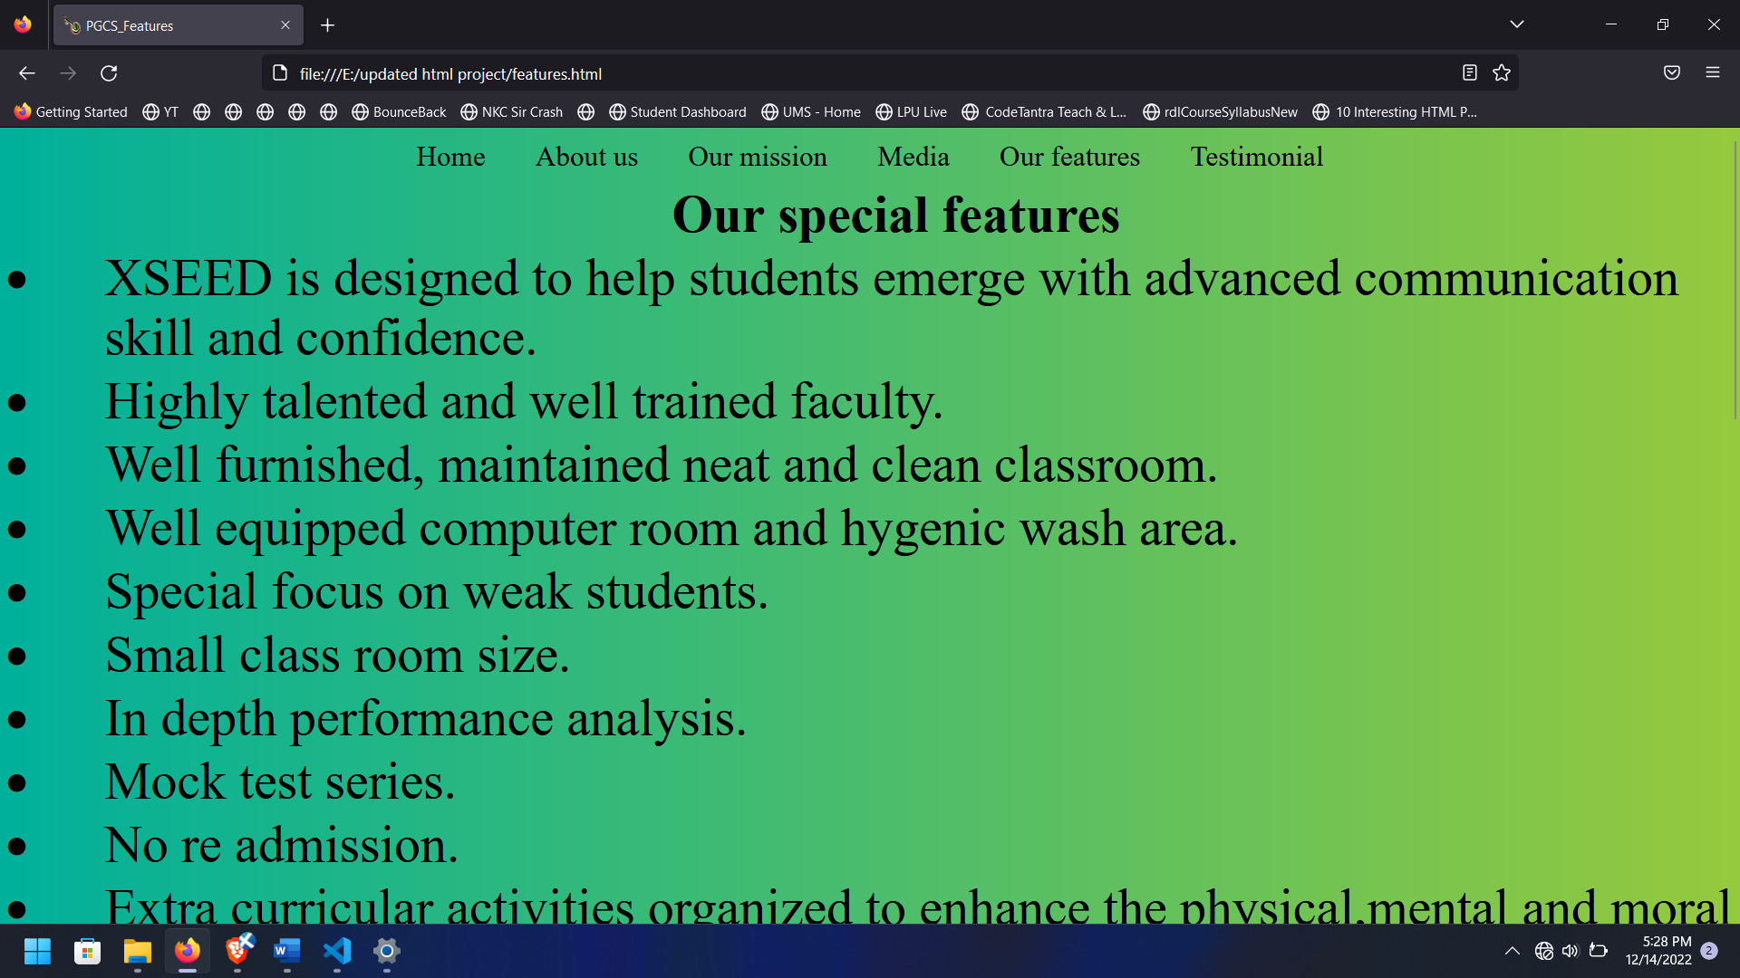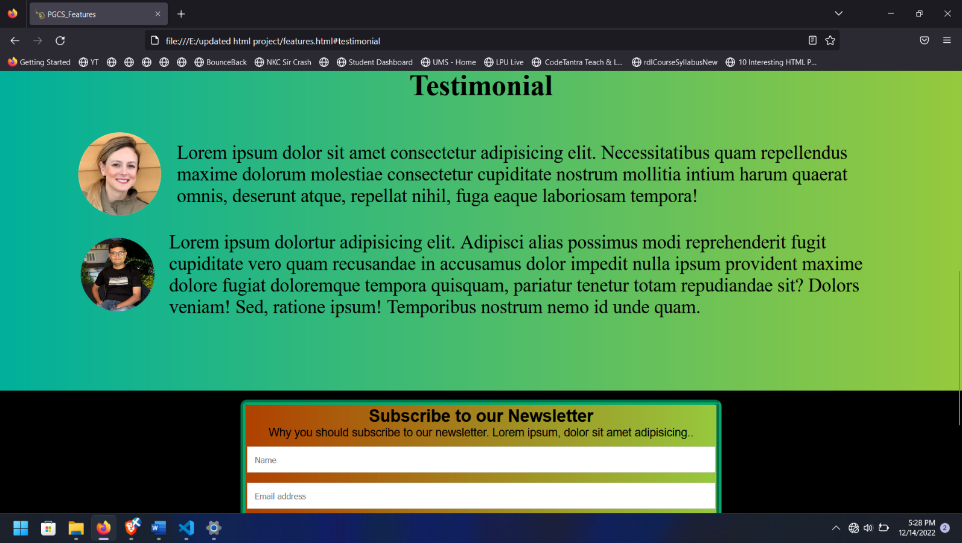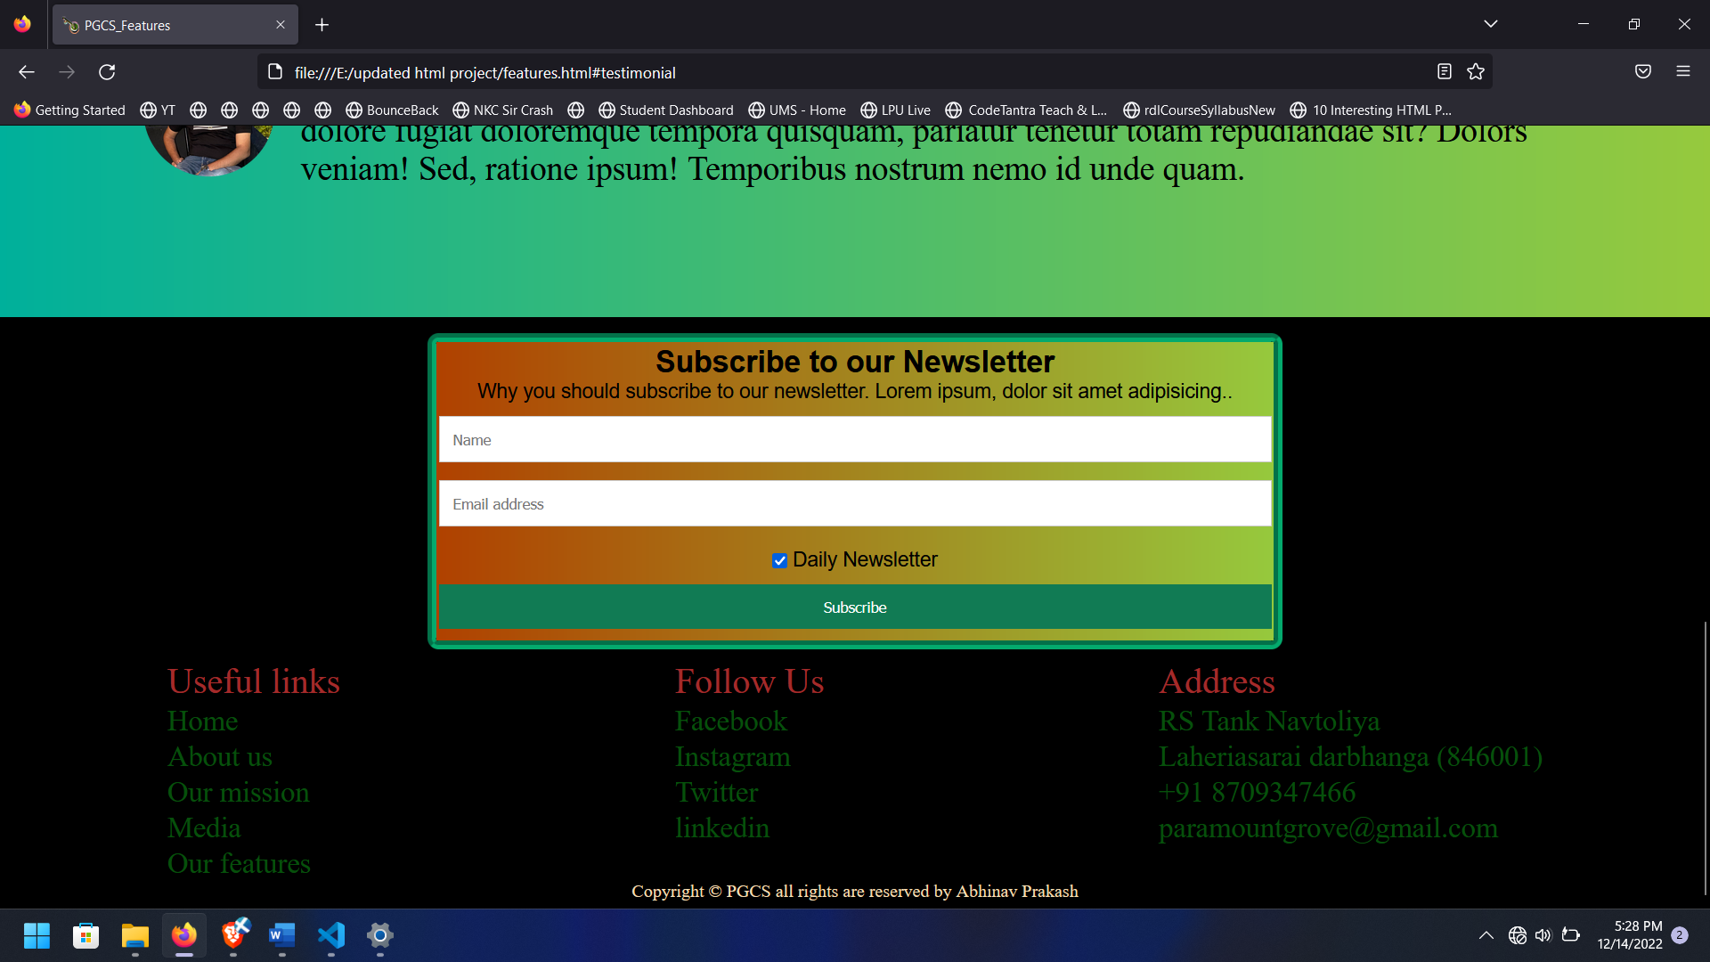

**6. Future scope of work**

* I will make my website host in future on google.
* I will work on adding more sections in my web page
* I will improve my design a better lot and will add a lot of customizations in my website.
* Will make partnership with others to understand the working of website more.
* Will work on backend as well in future
* I will add lot more options for live classes, attendance etc

**7. BONAFIDE CERTIFICATE**

Certified that this project report “School Website” is the bonafide work of “ABHINAV PRAKASH, SURYA PRAKASH REDDY, PRABHAT KUMAR SINGH” who carried out the project work under my supervision.

Sushil Lekhi